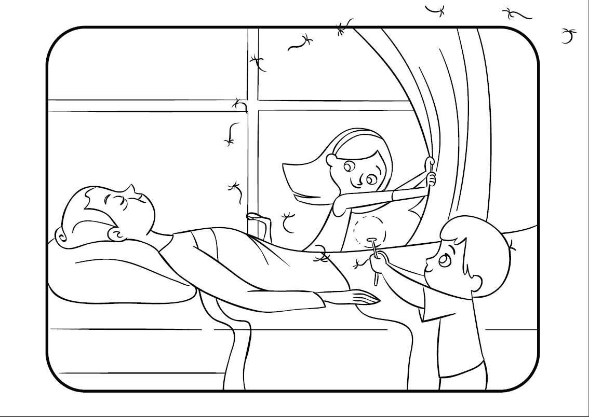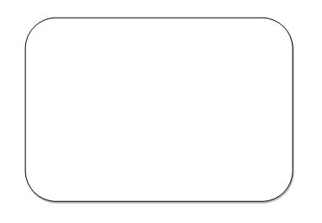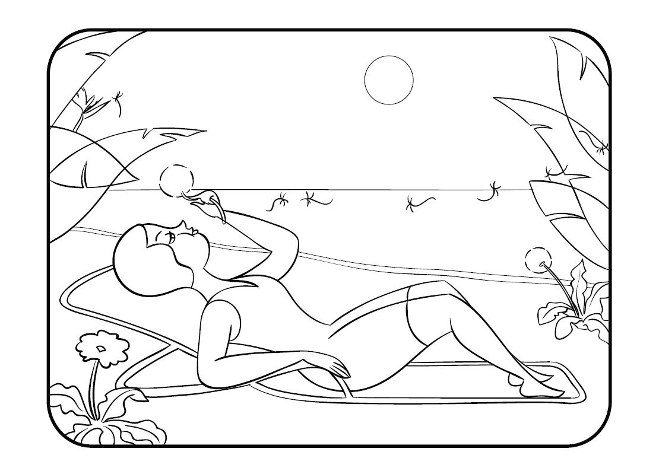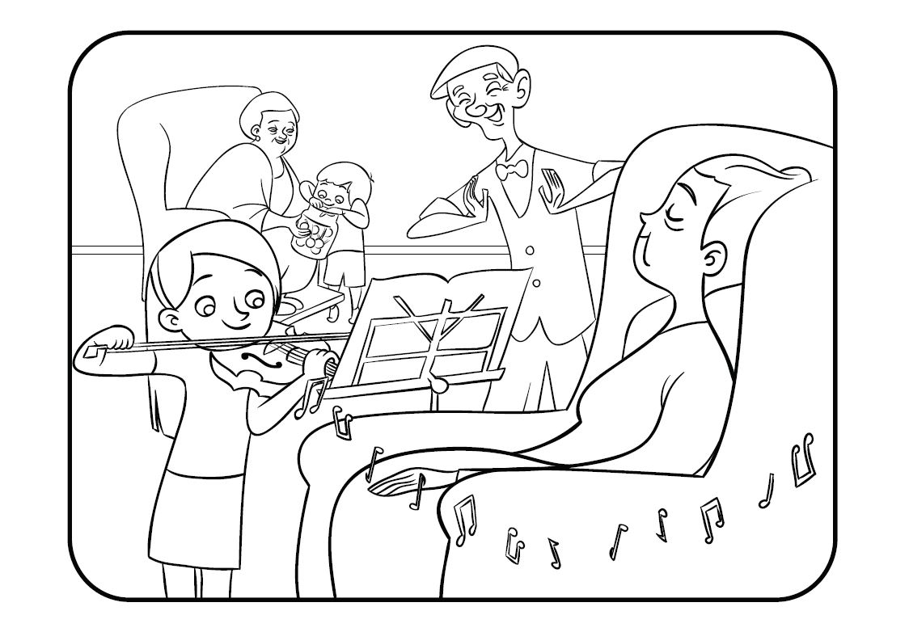

[www.wombatbooks.com.au](http://www.wombatbooks.com.au) (publisher)

[www.debratidball.com](http://www.debratidball.com) (author)

[www.leighhedstrom.com](http://www.leighhedstrom.com) (illustrator)

**When I see Grandma...**